

CIS 581 001 – COMPUTATIONAL LEARNING

MIDTERM PROJECT

POLYNOMIAL CURVE FITTING REGRESSION FOR WORKING-AGE DATA

|  |  |  |
| --- | --- | --- |
| NAME | : | SURYA SUBRAMANI |
| UMID | : | 69499602 |
| DATE OF SUBMISSION | : | 03-13-2023 |

1. The averages of the RMSE values obtained during the 6-fold CV for each case

|  |  |  |  |  |  |  |
| --- | --- | --- | --- | --- | --- | --- |
| **Sum of RMSE AVERAGE CV = 6** | **Degree** | | | | | |
| **Lambda** | **0** | **1** | **2** | **3** | **4** | **5** |
| 0 | 1.016 | 1.084 | 0.775 | 0.783 | 0.493 | 0.570 |
| e-25 | 1.016 | 1.084 | 0.775 | 0.783 | 0.493 | 0.570 |
| e-20 | 1.016 | 1.084 | 0.775 | 0.783 | 0.493 | 0.570 |
| e-7 | 1.016 | 1.084 | 0.776 | 0.783 | 0.494 | 0.571 |
| e-14 | 1.016 | 1.084 | 0.775 | 0.783 | 0.493 | 0.570 |
| e-3 | 1.035 | 1.097 | 0.795 | 0.812 | 0.550 | 0.642 |
| 1 | 2.168 | 2.178 | 2.974 | 3.173 | 3.002 | 3.074 |
| e3 | 23.982 | 24.287 | 23.427 | 23.609 | 25.006 | 25.303 |
| e7 | 63.681 | 63.713 | 61.974 | 62.093 | 58.273 | 58.478 |
| **Sum of RMSE AVERAGE CV = 6** | **Degree** | | | | | |
| **Lambda** | **7** | **8** | **9** | **10** | **11** | **12** |
| 0 | 0.188 | 0.146 | 0.236 | 0.165 | 0.626 | 0.687 |
| e-25 | 0.188 | 0.146 | 0.236 | 0.165 | 0.626 | 0.687 |
| e-20 | 0.188 | 0.146 | 0.236 | 0.165 | 0.626 | 0.687 |
| e-7 | 0.185 | 0.133 | 0.191 | 0.127 | 0.099 | 0.432 |
| e-14 | 0.142 | 0.188 | 0.146 | 0.236 | 0.165 | 0.624 |
| e-3 | 0.238 | 0.344 | 0.461 | 0.242 | 0.305 | 0.469 |
| 1 | 3.532 | 2.945 | 3.042 | 3.392 | 4.012 | 3.845 |
| e3 | 24.435 | 24.239 | 24.619 | 27.148 | 29.966 | 30.190 |
| e7 | 55.010 | 58.115 | 59.655 | 62.302 | 66.737 | 62.201 |

1. The optimal degree d∗ and regularization parameter λ∗ obtained via the 6-fold CV

d* = **11**, λ∗ = **e-7**

RMSE Average is **0.987**

1. The coefficient-weights of the d∗-degree polynomial and the λ∗-regularized 12-degree learned on all the training data

Weights for d* = **11**, λ∗ = **e-7** 6 fold CV

|  |  |  |  |  |  |  |
| --- | --- | --- | --- | --- | --- | --- |
| weights/folds | 1 | 2 | 3 | 4 | 5 | 6 |
| w0 | 65.456 | 65.49 | 65.462 | 65.495 | 65.469 | 65.464 |
| w1 | 0.455 | 0.463 | 0.473 | 0.644 | 0.495 | 0.519 |
| w2 | 5.41 | 5.208 | 5.35 | 4.636 | 5.293 | 5.376 |
| w3 | 0.02 | -0.257 | -0.071 | -0.315 | -0.305 | -0.301 |
| w4 | -6.801 | -6.252 | -6.69 | -4.981 | -6.674 | -6.789 |
| w5 | 0.273 | 0.698 | 0.318 | 0.216 | 0.86 | 0.575 |
| w6 | 3.377 | 2.789 | 3.27 | 1.773 | 3.376 | 3.373 |
| w7 | -0.375 | -0.575 | -0.327 | -0.023 | -0.836 | -0.387 |
| w8 | -0.94 | -0.686 | -0.893 | -0.336 | -0.987 | -0.931 |
| w9 | 0.211 | 0.234 | 0.172 | 0.017 | 0.385 | 0.15 |
| w10 | 0.115 | 0.078 | 0.108 | 0.034 | 0.13 | 0.112 |
| w11 | -0.037 | -0.035 | -0.031 | -0.006 | -0.063 | -0.023 |

Weights for d* = **11**, λ∗ = **e-7** , all training data

|  |  |  |  |  |  |  |  |  |  |  |  |
| --- | --- | --- | --- | --- | --- | --- | --- | --- | --- | --- | --- |
| w0 | w1 | w2 | w3 | w4 | w5 | w6 | w7 | w8 | w9 | w10 | w11 |
| 65.469 | 0.500 | 5.303 | -0.218 | -6.615 | 0.558 | 3.222 | -0.494 | -0.880 | 0.224 | 0.107 | -0.036 |

Weights for d = **12**, λ∗ = **e-7** , all training data

|  |  |  |  |  |  |  |  |  |  |  |  |  |
| --- | --- | --- | --- | --- | --- | --- | --- | --- | --- | --- | --- | --- |
| w0 | w1 | w2 | w3 | w4 | w5 | w6 | w7 | w8 | w9 | w10 | w11 | w12 |
| 65.472 | 0.510 | 5.202 | -0.315 | -6.076 | 0.800 | 2.276 | -0.733 | -0.166 | 0.326 | -0.135 | -0.052 | 0.030 |

1. The training and test RMSE of that final, learned polynomials

Weights and RMSE for optimal Model d* = **11**, λ∗ = **e-7**, all training data

|  |  |  |  |  |  |  |  |  |  |  |  |
| --- | --- | --- | --- | --- | --- | --- | --- | --- | --- | --- | --- |
| w0 | w1 | w2 | w3 | w4 | w5 | w6 | w7 | w8 | w9 | w10 | w11 |
| 65.469 | 0.500 | 5.303 | -0.218 | -6.615 | 0.558 | 3.222 | -0.494 | -0.880 | 0.224 | 0.107 | -0.036 |

RMSE for Training: 0.06626

RMSE for Test: 0.3944

Weights and RMSE for d = **12**, λ∗ = **e-7** , all training data

|  |  |  |  |  |  |  |  |  |  |  |  |  |
| --- | --- | --- | --- | --- | --- | --- | --- | --- | --- | --- | --- | --- |
| w0 | w1 | w2 | w3 | w4 | w5 | w6 | w7 | w8 | w9 | w10 | w11 | w12 |
| 65.472 | 0.510 | 5.202 | -0.315 | -6.076 | 0.800 | 2.276 | -0.733 | -0.166 | 0.326 | -0.135 | -0.052 | 0.030 |

RMSE for Training: 0.06766

RMSE for Test: 0.5594

1. The 2 plots containing all the training data along with the  
   resulting polynomial curves for d∗ and λ∗, for the range of years 1968-2023 as input

Combined Graph:

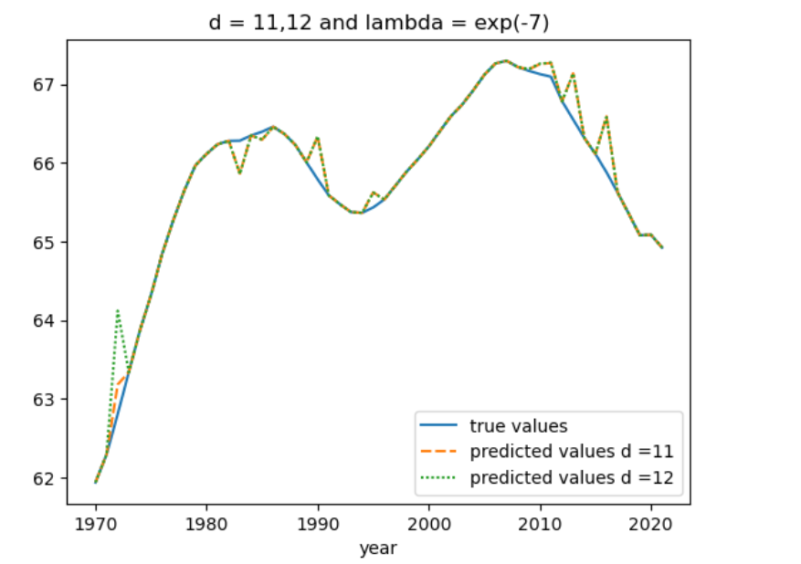

Individual graphs:

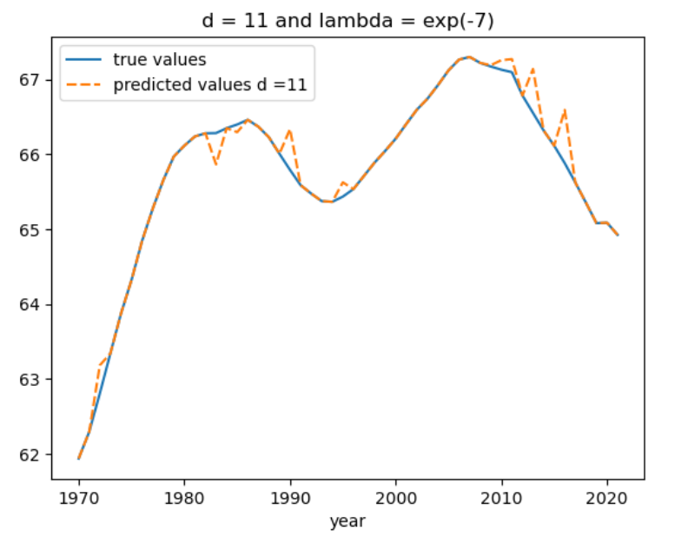 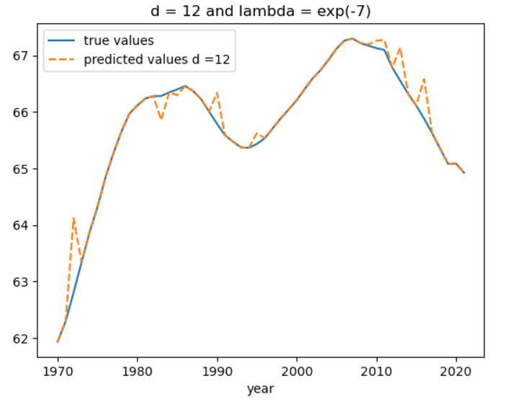

1. Brief discussion of your findings and observations.

From the data and the graph, we can able to observe that for every 20 years the age indicator goes to the peak and starts descending. This repeats for every 30 years with an increase in indicator.

|  |  |  |
| --- | --- | --- |
| **Criteria** | **Year** | **True Values** |
| **count** | 42 | 42 |
| **mean** | 1994.80952 | 65.70398 |
| **std** | 15.209493 | 1.181847 |
| **min** | 1970 | 61.93886 |
| **25%** | 1981.25 | 65.35731 |
| **50%** | 1995 | 65.98761 |
| **75%** | 2005.75 | 66.36326 |
| **max** | 2021 | 67.29843 |

*(the above shown Data is before scaling)*

To reduce the standard deviation, which can affect the model training, The input matrix is scaled to minimum values using (X-mean)/std.

|  |  |  |
| --- | --- | --- |
| **Criteria** | **Year** | **True Values** |
| **count** | 42.00 | 42.00 |
| **mean** | 0.00 | 65.70 |
| **std** | 1.00 | 1.18 |
| **min** | -1.63 | 61.94 |
| **25%** | -0.89 | 65.36 |
| **50%** | 0.01 | 65.99 |
| **75%** | 0.72 | 66.36 |
| **max** | 1.72 | 67.30 |

*(the above shown Data is after scaling)*

To train model and calculate weights I have used the below equation

|  |
| --- |
| W = (XT.X + lambda*I).XT.y |

Which is the derivation of

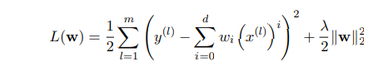

Exp(7) gives higher RMSE a